**LAB PLAN**

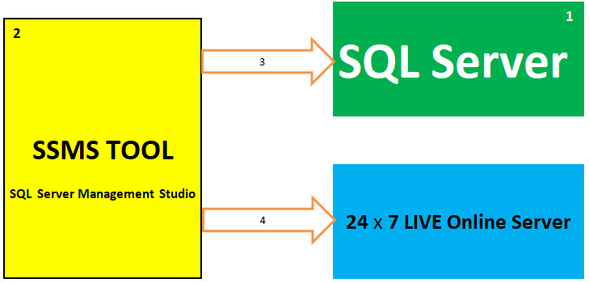

|  |  |  |
| --- | --- | --- |
| **OS REQUIREMENTS** | | |
| **VERSION NAME** | **VERSION NUMBER** | **INSTALLATION REQUIREMENTS** |
| **SQL Server 2019** | **15.0** | **WINDOWS 8 OR HIGHER. 64 bit & LINUX** |
| **SQL Server 2017** | **14.0** | **WINDOWS 8 OR HIGHER. 64 bit & LINUX** |
| **SQL Server 2016** | **13.0** | **WINDOWS 8 OR HIGHER. 64 bit** |
| **SQL Server 2014** | **12.0** | **WINDOWS 7 OR HIGHER. 64 bit / 32bit** |
| **HARDWARE REQUIREMENTS** | | |
| **4 GB RAM** | **4 GB DISK SPACE** | **Any Processor that supports above OS** |

**Task 1: SQL Server Installation**

**STEP 1: Download SQL Server from:** [**https://sqlschool.com/downloads/**](https://sqlschool.com/downloads/) **Right Click > Extract:**

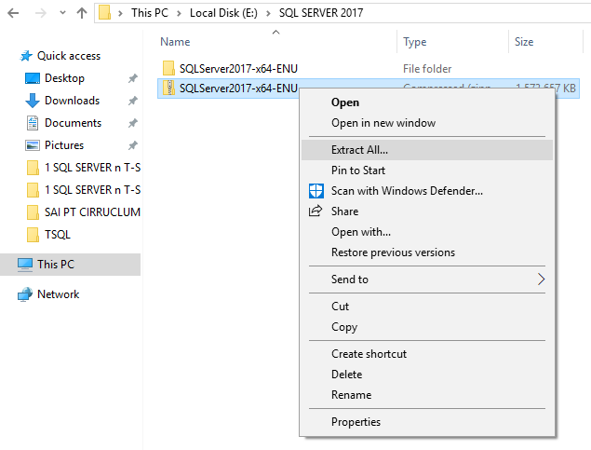

**STEP 2: Double Click Setup Application File [Green Icon] :** 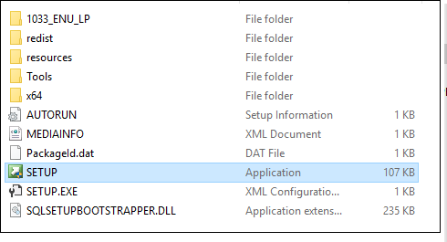

**STEP 3: WE GET “INSTALLATION CENTER” SCREEN > GO TO INSTALLATION PAGE > NEW INSTALLATION**

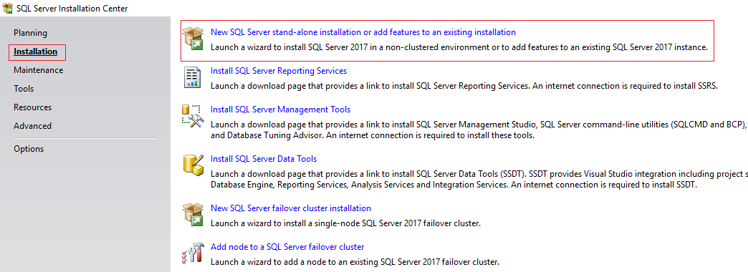

**STEP 4: Click Next > SELECT EVALUATION EDITION > Accept Licensing Terms > Click Next :**

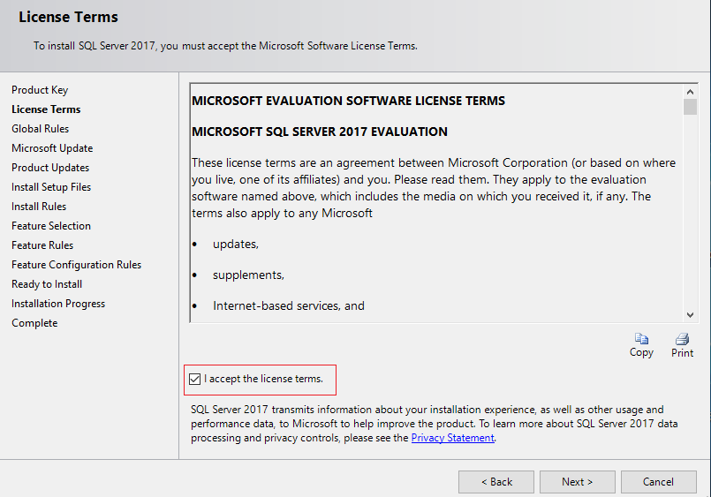

**STEP 5: Click Next > Select Database Engine Component > Click Next :**

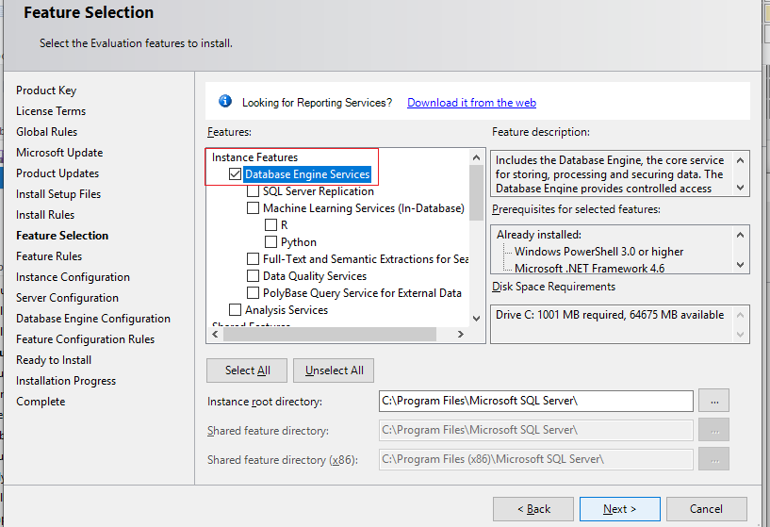

**STEP 6: Specify a Name to your Server = INSTANCE NAME > Click Next :**

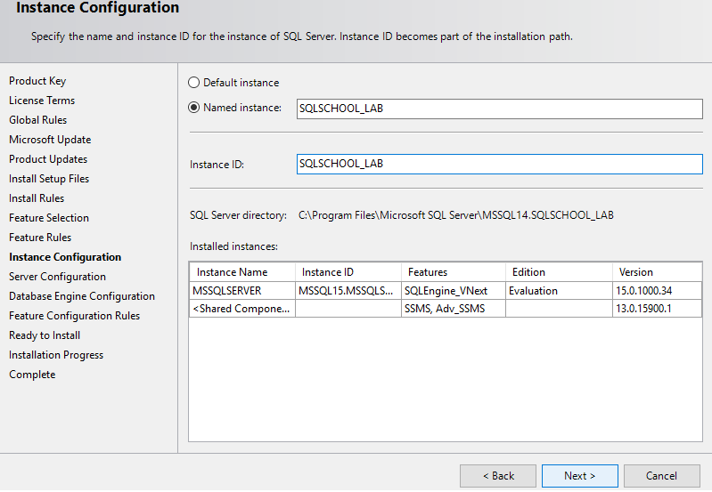

**STEP 7: Click Next > Add Current User :**

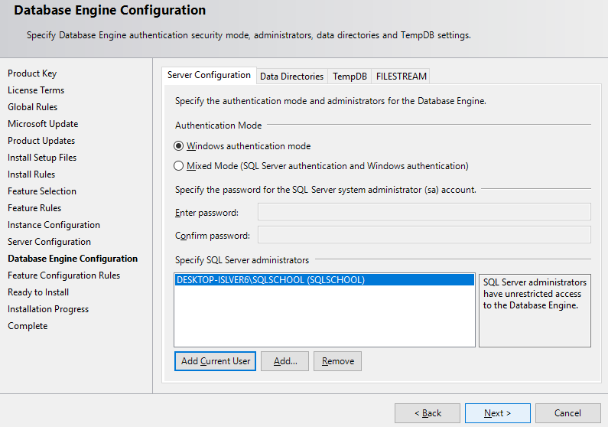

**STEP 8: Install :**

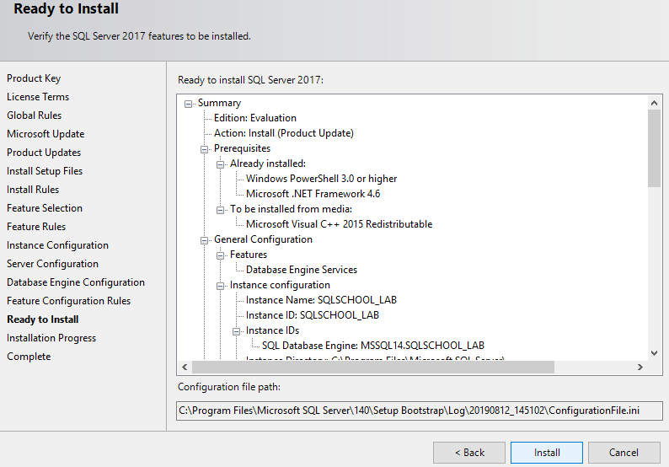

**TASK 2: SSMS TOOL INSTALLATION**

**STEP 1: Download SSMS TOOL from:** <https://sqlschool.com/downloads/>

**STEP 2: Right Click downloaded SQL Server File > Extract > Double Click ENU File :** 